Touch Keyboard Requirements
The following requirements are in Gherkin format.

What happens when a key is pressed and released

- Given my finger is over C1 key
- When I touch the key without releasing
  - Then I get MIDI Control Change message on Channel 1
    - And Controller is 4AH (74 decimal) labeled "Brightness" in MIDI manual
    - And Control Value is between 0 and 127 depending the closest electrode to my fingertip when the key is touched (see Mapping below)
  - Then I get MIDI Note On message on Channel 1
    - And Pitch is C1
    - And Velocity is always 127 (maximum velocity)

- When I slide my finger along C1 key without releasing
  - Then I get MIDI Control Change message on Channel 1
    - And Controller is 4AH (74 decimal) labeled "Brightness" in MIDI manual
    - And Control Value is between 0 and 127 depending on the closest electrode to my fingertip as my finger is moving (see Mapping below)

- When I release the key
  - Then I get MIDI Control Change message on Channel 1
    - And Controller is 4AH (74 decimal) labeled "Brightness" in MIDI manual
    - And Control Value is between 0 and 127 depending the closest electrode to my fingertip when the key is touched (see Mapping below)
  - Then I get MIDI Note Off message on Channel 1
    - And Pitch is C1
    - And Velocity is always 0 (minimum velocity)

What happens when a second key is pressed while the first is still held down

The keyboard should maintain monophonic behavior: only one key can be registered as pressed at the same time. If a second key is pressed while the first is still held down, Note Off is sent for the first key and Note On for the second key. This is described by the following requirement:

- Given my finger is over C1 key
- When I touch any of the electrodes within this key
  - Then I get MIDI Control Change message on Channel 1
    - And Controller is 4AH (74 decimal) labeled "Brightness" in MIDI manual
    - And Control Value is between 0 and 127 depending the closest electrode to my fingertip when the key is touched (see Mapping below)
  - Then I get MIDI Note On message on Channel 1
    - And Pitch is C1
    - And Velocity is always 127 (maximum velocity)
- When I touch any of the electrodes within C2 key while still holding down C1 key
  - Then I get MIDI Control Change message on Channel 1
    - And Controller is 4AH (74 decimal) labeled "Brightness" in MIDI manual
    - And Control Value is between 0 and 127 depending the closest electrode to my fingertip when the key is touched (see Mapping below)
  - Then I get MIDI Note Off message on Channel 1
    - And Pitch is C1
    - And Velocity is always 0 (minimum velocity)
  - Then I get MIDI Note On message on Channel 1
    - And Pitch is C2
    - And Velocity is always 127 (maximum velocity)
- When I release the key
  - Then I get MIDI Control Change message on Channel 1
    - And Controller is 4AH (74 decimal) labeled "Brightness" in MIDI manual
    - And Control Value is between 0 and 127 depending the closest electrode to my fingertip when the key is touched (see Mapping below)
  - Then I get MIDI Note Off message on Channel 1
    - And Pitch is C2
    - And Velocity is always 0 (minimum velocity)

Control Change Controller

The following excerpt from The Complete MIDI 1.0 Detailed Specification lists value 74 for the Control Change controller called “Brightness”:

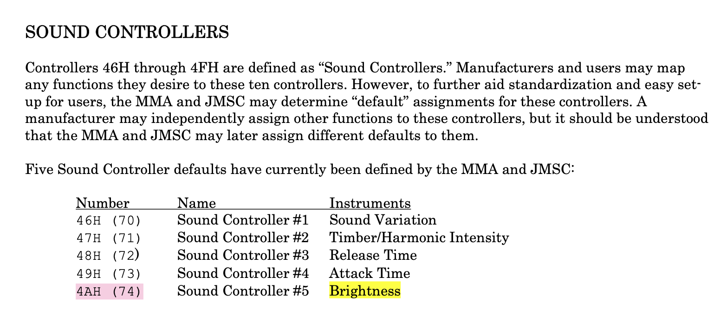

Control Change Mapping

Each key has 13 electrodes, indexed from 0 to 12 (counting from bottom to top).
Electrode 0 (bottom) generates MIDI Control Change Value 0.
Electrode 12 (top) generates MIDI Control Change Value 127.
Electrodes in between generate respective values according to this formula:
CC Value = Round(Index / 12 * 127)
CC Controller is constant (always 74) which maps to “Brightness” sound controller.

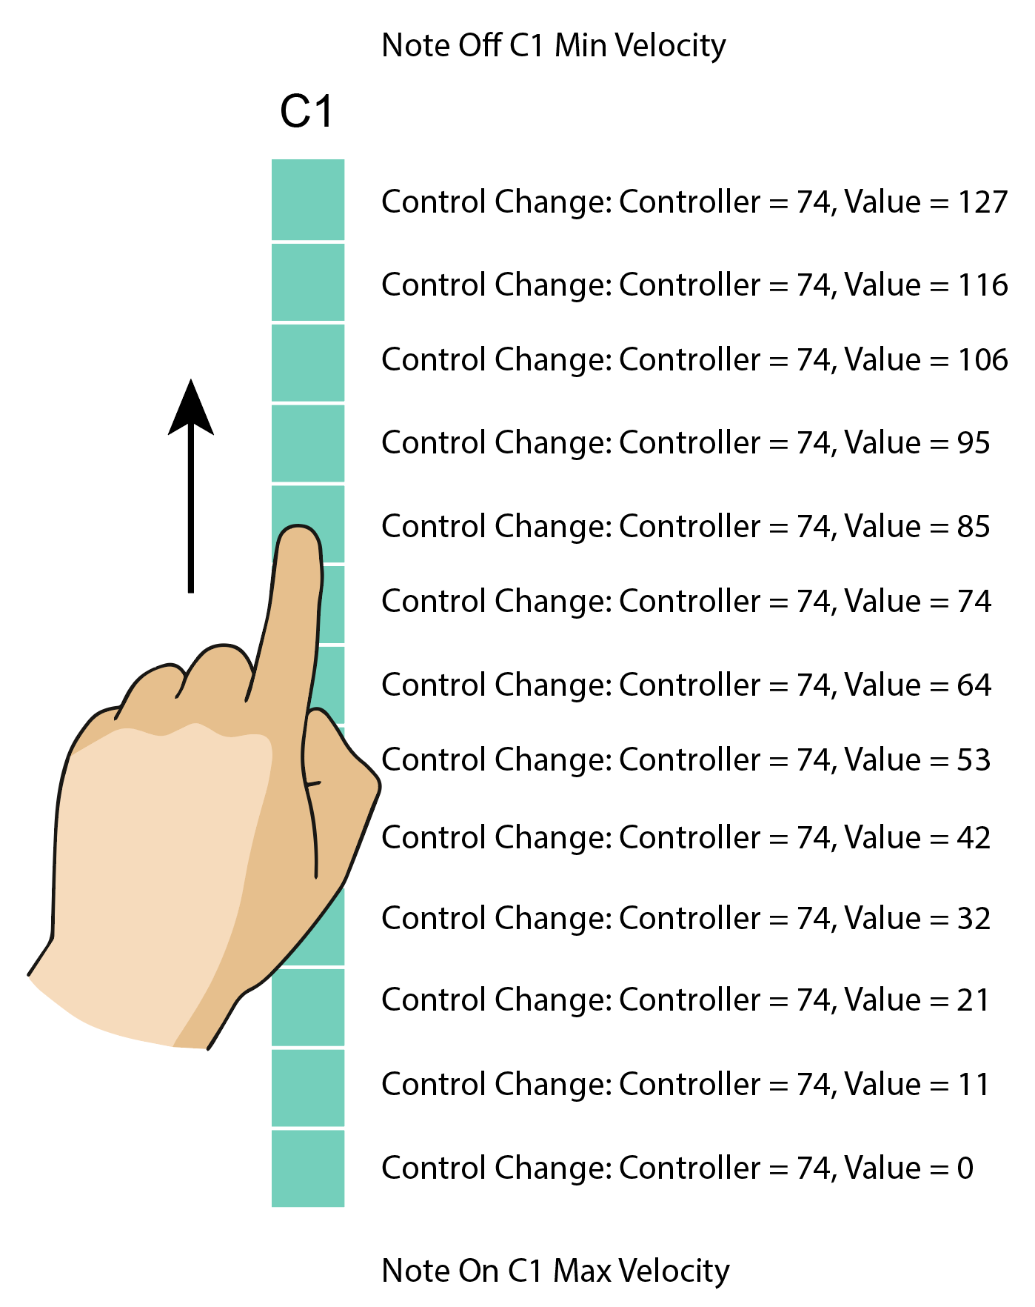

Summary:
- Electrode 0: CC Value 0
- Electrode 1: CC Value 11
- Electrode 2: CC Value 21
- Electrode 3: CC Value 32
- Electrode 4: CC Value 42
- Electrode 5: CC Value 53
- Electrode 6: CC Value 64
- Electrode 7: CC Value 74
- Electrode 8: CC Value 85
- Electrode 9: CC Value 95
- Electrode 10: CC Value 106
- Electrode 11: CC Value 116
- Electrode 12: CC Value 127

Monitoring MIDI Output

You can install MIDI Monitor by Snoize to check MIDI messages output from the device during development.

https://www.snoize.com/MIDIMonitor/

The following output has been captured from ROLI Seaboard, which fits the specification above (except for the Channel being 3 instead of 1, and different Velocities).

